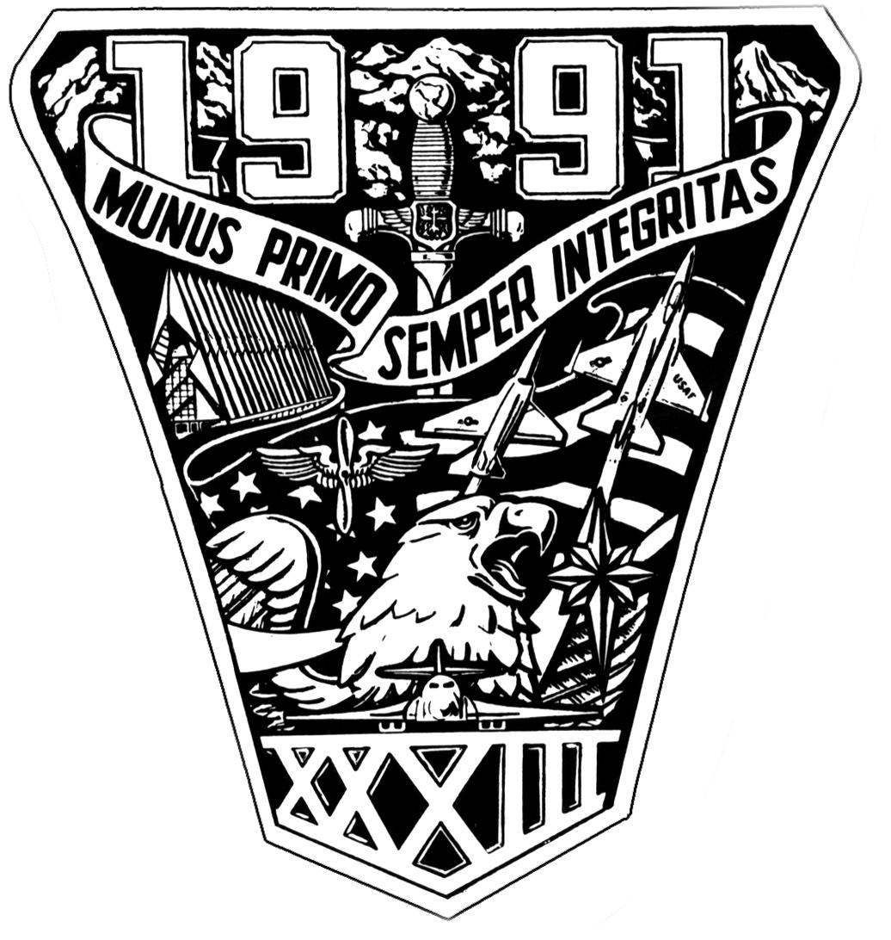
UNITED STATES AIR FORCE ACADEMY
CLASS OF 1991
35th Reunion 30 Sept-4 Oct 2026 Colorado Springs, Colorado
REUNION MESSAGE #2

The moment we've been building toward — hotel reservations for our 35th Reunion is officially open!

Our headquarters hotel is the Colorado Springs Marriott (Tech Center Drive), and we've secured a class block at a group rate. Rooms will go fast, so I encourage you to book early to lock in your spot.
Book your room here: https://app.marriott.com/reslink?id=1776188401619&key=GRP...

A few things to keep in mind:
• The group rate is available on a first-come, first-served basis.
• Be sure to book under the USAFA Class of 1991 block to get the discounted rate.
• If you have any issues with the reservation link, reach out to me directly.
For those still on the fence — this is shaping up to be a weekend to remember. We'll be together for the Air Force vs. Navy game, a Friday night reception, a memorial service honoring our fallen classmates, and much more. Details on the full schedule are coming soon.

If you made hotel reservations outside of the Reunion Reservations. IM your name and reservation number. We will get it moved under the reservation and at the group rate. If you made reservations using points...keep them the way they are!

Bold Gold,
Heidi

